**Introduction to Cloud Computing**

**What is Cloud Computing?**

This means accessing cloud resources over the network

**Types of Cloud Computing?**

1. 1Infrastructure as a Service (IAAS)

* This means users manage the maintenance of IT resources. It provides access to networking features, computers (virtual or on dedicated hardware), and data storage. Iaas gives you the highest level of flexibility and management control over your IT resources.

1. Platform as a Service (PaaS)

* This helps the user to be more efficient as you don’t need to worry about resource procurement, capacity planning, software maintenance, patching, or any of the other undifferentiated heavy lifting involved for the user when running their application

1. Software as a Service (SaaS)

* With a SaaS offering, users don’t have to think about how the service is maintained or how the underlying infrastructure is managed. The user only needs to think about how they will use that particular software

**Elastic Cloud Computing (EC2) Features**

* EC2 provides web services API for provisioning, managing, and de-provisioning virtual servers inside the Amazon cloud
* Ease in scaling UP/Down
* Pay only for what you use
* Can be integrated into several other services

**EC2 Pricing**

1. On Demand

* Pay per hour or seconds

1. Reserved

* Reserve Capacity (1 or 3 years) for discounts

1. Spot

* Bid your price for unused ec2 capacity

1. Dedicated Hosts

* Physical Server dedicated to you

**Elastic Cloud Computing (EC2) Components**

1. AMI

* Amazon Machine Image (AMI) provides the information required to launch an instance, which is a virtual server in the cloud

1. Instance Type (M4 InstanceC4, Instance F1, Instance 13, Instance)

* When you launch an instance, the instance type that you specify determines the hardware of the host computer used for your instance

1. Amazon Elastic Block Store (EBS)

* Amazon EC2 provides you with flexible, cost effective, and easy-to-use data storage options for your instance

1. Tags

* A simple label consisting of a customer-defined key and an optional value that can make it easier to manage, search for, and filter resources

1. Security Group Instance

* A security group acts as a virtual firewall that controls the traffic for one or more instances
* You can add rules to each security group that allow traffic to or from its associated instances
* Security groups are “Stateful”
* Security Rules:
* Inbound Rules – Traffic coming from outside on the instance (ssh)
* Outbound Rules – Traffic going from instance to outside (downloading software)

1. Key Pair

* Amazon EC2 uses public-key cryptography to encrypt and decrypt login information

**Creation of EC2 Instance**

* Amazon EC2
* Choose an AMI
* Choose an Instance Type
* Configuring the instance
* Adding Storage (EBS)
* Add Tags
* Configure Security Group
* Review
* Best way to create EC2 instance:
* Key pairs
* Security Group
* Instance Launch

**EC2 Elastic IP**

Enables user to get a permanent and not changing IP address

**AWS CLI Commands for configuration and user verification**

* aws configure – Configures the user access key, region, and data format (eg JSON)
* ls ~/.aws – This directory contains the user's configurations and credentials
* aws sts get-caller-identity – Displays the user’s identity

**Elastic Block Storage (EBS)**

* Block-based storage
* Runs ec2 OS, stores data from a database, file data, etc.
* Placed in specific AZ. Automatically replicated within the AZ to protect from failure
* Snapshot is a backup of a volume

**Elastic Block Storage Types**

1. General Purpose (SSD)

* Most work loads

1. Provisioned IOPS

* Large databases

1. Throughput Optimized HD

* Big data & data warehouses

1. Cold HDD

* File Servers

1. Magnetic

* Backup & Archives

**Elastic Block Storage Commands**

* fdisk –l – Shows the attached hard disk
* df –h – command for mounting
* fdisk <name of attached hard disk> - Used to create a new partition
* mkfs.ext4 <created partition path> - Linux formatting (.ext4 – extension type)
* mount <partition name> <path to mount>
* unmount <path name> - to unmount a partition
* vim /etc/fstab -> go to last line -> <partition path> <path to mount> <format eg. ext4> defaults option 0 0 – This is used to mount permanently
* mount –a – To read the fstab file and mount everything

**Load Balancer and Why We Need Them?**

* Cluster of servers needs endpoint
* Endpoint are usually of a Load Balancer
* Load Balancer balances incoming traffic to backend servers

**Load Balancer Ports**

* Frontend ports: Listens from the user requests on this port AKA listeners
  + E:g 80 HTTP, 443 HTTPS, 25 SSH, etc
* Backend ports: Services running on OS listening on this port
  + E:g 80 HTTP, 443 HTTPS, 25 SSH, etc

**Elastic Load Balancer**

* Elastic load balancing distributes incoming applications or network traffic across multiple targets in multiple availability zones, such as Amazon EC2 instances, containers, and IP addresses.
* Elastic Load Balancing supports three types of load balancers:
  + Application Load Balancer – Layer seven Load Balancer
    - Application Load Balancer that routes traffic based on advanced application-level information that includes the content of the request
  + Network Load Balancer
    - A Network Load Balancer functions at the fourth layer of the Open Systems Interconnection (OSI) model
    - It can handle millions of requests per second
    - Static IP
  + Classic Load Balancer – Layer four Load Balancer
    - The Classic Load Balancer that routes traffic based on either application or network-level information
    - The Classic Load Balancer is ideal for simple load balancing of traffic across multiple EC2 instances
  + Gateway Load Balancer

**Creating Load Balancer procedure**

* Create an Instance
* Create an AMI
* Launch Template
* Create Target Group
* Create Load Balancer

**Cloud Watch**

This is a monitoring system in Amazon Web Services (AWS), where most monitoring is configured.

**Cloud Watch features**

* Cloud Watch – Monitors performance of AWS environment – standard infrastructure metrics
* Metrics – AWS cloud watch allows users to record metrics for services such as EBS, EC2, ELB, Route53 Health checks, RDS, Amazon S3, Cloudfront, etc
* Events – AWS Events delivers a near real-time stream of system events that describe changes in Amazon Web Services (AWS) resources
* Logs – Users can use Amazon CloudWatch Logs to monitor, store, and access users log files from Amazon Elastic Compute Cloud (Amazon EC2) instances, AWS CloudTrail, Route 53, and other sources

**Cloud Watch Alarm**

* This is an alarm that monitors CloudWatch metrics for instances
* Email Notification – Simple Notification Service (Amazon SNS) is a web service that coordinates and manages the delivery or sending of messages to subscribing endpoints or clients
* Ways to create a CloudWatch Alarm:
  + EC2 instance
  + Create Alarm
  + Amazon CloudWatch
  + Alarm
  + Alarm triggered
  + Email notification

**Relational Databases**

This is a service provided by Amazon Web Services, for managing and running RDS, and it’s a distributed relational database service it provides:

* High Availability Multi-AZ deployments
* Effortless scaling
* Read Replicas for performance

**DB Administration**

* Installs
* Patching
* Monitoring
* Performance Tuning
* Backups
* Scaling
* Security
* Hardware Upgrades
* Software Management

**RDS Connection with MySQL**

Mysql –h <Endpoint> u- <username> -p<password>

**Simple Storage Service (S30), and what is S3?**

Amazon Simple Storage Service (S3) is a storage for the internet. You can use Amazon S3 to store and retrieve any amount of data anytime, from anywhere on the web.

**S3 Basic**

* It is an object-based storage
* Data is replicated across multiple facilities
* Unlimited storage
* Amazon S3 stores data as an object within buckets
* Buckets name has to be unique
* S3 stores data in the following:
  + S3 Bucket
    - A bucket is a logical unit of storage in Amazon Web Services (AWS)
  + Object
    - Object storage is a computer data storage architecture that manages data as objects

**Creation of Simple Storage Service (S3)**

* Amazon S3
* Bucket
* Folder
* Object
* Public Access

**S3 Storage Classes**

* S3 Standard
  + General-purpose storage of frequently accessed data. Fast access & object replication in Multi-AZ
* S3 IA – Infrequent Access
  + Long-lived, but less frequently accessed data. Slow access, and object replication in multi-AZ
* S3 One Zone-IA
  + Is for data that is accessed less frequently, but requires rapid access when needed, Slow access, no object replication
* S3 Intelligent Tiering
  + Automatically moves data to the most cost-effective tier
* S3 Glacier
  + Low-cost storage class for data archiving
* S3 Glacier Deep Archive
  + Lowest cost storage, retrieval time of 12hrs

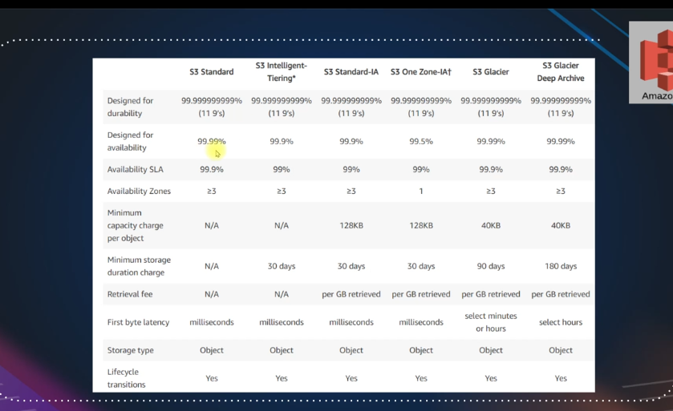

**S3 Charges**

* Storage
* Requests
* Tiers
* Data Transfer
* Region Replication